**Cerner to PatientSafe ADT Requirements**

**Version 1.0**

**Prepared By: Levy Lazarre**

**Date: 1/28/2019**

Document Control 3

Resources 3

Project Distribution List 3

Document Version Control 3

1. Introduction 4

1.1 Purpose 4

1.2 Project Scope 4

1.3 Terminology Standards 4

1.3.1 Acronyms 4

1.3.2 Glossary 4

1.4 Document References 4

2. Diagram 5

3. Requirements 6

3.1 Functional Requirements 6

3.2 Non-Functional Requirements 6

3.3 Messaging Protocols 6

3.3.1 Inbound to the BayCare Cloverleaf From Cerner 7

3.3.2 Outbound to PatientSafe 7

4. HL7 Messaging 7

4.1 Messaging Format 7

4.1.1 Segments 7

4.1*.*2 Messaging Event Types 7

4.1*.*3 Cloverleaf Configuration Files 8

4.1.4 Cloverleaf Site Location 8

4.2 Data Transformation Requirements 8

4.3 Sample Message 8

Appendix A: Risks and Concerns 10

Appendix B: Issues List 10

# **Document Control**

## Resources

|  |  |  |
| --- | --- | --- |
| **Name** | **Role** | **Email** |
| Derek Richae | Innovation Analyst  Project Manager, BayCare | Derek.Richae @baycare.org |
| Blake Basquin | Senior Project Manager  PatientSafe Solutions | bbasquin@patientsafesolutions.com |
| Sean Payne | Principal Software Solutions Engineer  PatientSafe Solutions | SPayne@patientsafesolutions.com |
| Urvashi Parmar | Associate Software Engineer  PatientSafe Solutions | UParmar@patientsafesolutions.com |
| Sailaja Parimi | Integration Analyst, BayCare EIT | Sailaja.Parimi @baycare.org |
| Levy Lazarre | Integration Analyst, Baycare EIT | Levy.Lazarre@baycare.org |
| Vanja Karabasic | Systems Analyst  APPS – DOCUMENTATION/ORDERS | Vanja.Karabasic @baycare.org |
| Janet Dowell | Systems Analyst – DEPT SPEC  LAB COMPUTER | Janet.Dowell@baycare.org |
| Pattie D. Cone | IT Lead - CBO  CBO MANAGEMENT SUPPORT | Patricia.Cone@baycare.org |

## Project Distribution List

## Document Version Control

|  |  |  |  |
| --- | --- | --- | --- |
| **Version** | **Date** | **Modifier** | **Description** |
| V1.0 | 01/28/2019 | Levy Lazarre | Original document |
|  |  |  |  |
|  |  |  |  |
|  |  |  |  |

# 1. Introduction

## 1.1 Purpose

The purpose of this document is to describe the ADT Interface going from Cerner EMR to PatientSafe Solutions.

**PatientTouch** is a PatientSafe application used by physicians, nurses, and other clinicians for collaboration in patient care. It runs on a smartphone and consolidates secure messaging, voice, alerts, and nurse calls with EMR data and clinical workflows in one mobile app on one device.

## 1.2 Project Scope

The scope of this project is to automate the integration of the PatientSafe Solutions PatientTouch application with the Soarian HIS via HL7 ADT interface and the Cerner EMR via HL7 ADT and Results interfaces. There is also integration of Orders via Sansoro API. **The current document describes the ADT interface from Cerner EMR to PatientSafe for the purpose of sending patient allergy** **information to PatientSafe.**

## 1.3 Terminology Standards

### 1.3.1 Acronyms

**ADT** – Admission, Discharge, Transfer: mainly demographic and patient location data

**HIS** – Health Information System, the source and keeper of patient demographic data

**PSS** – PatientSafe Solutions

### 1.3.2 Glossary

**ADT Event** – Trigger event associated with a patient event: registration, admission, discharge, transfer, update…

## 1.4 Document References

1. IP_Baycare_Workflow_101718.pdf

2. ADT Test cases.rev0-20181126.xlsx

# 2. Diagram

Provide a solution diagram that depicts the integration of components specified in this IDBB. This diagram must include the data flow for the interfaces (source and target).

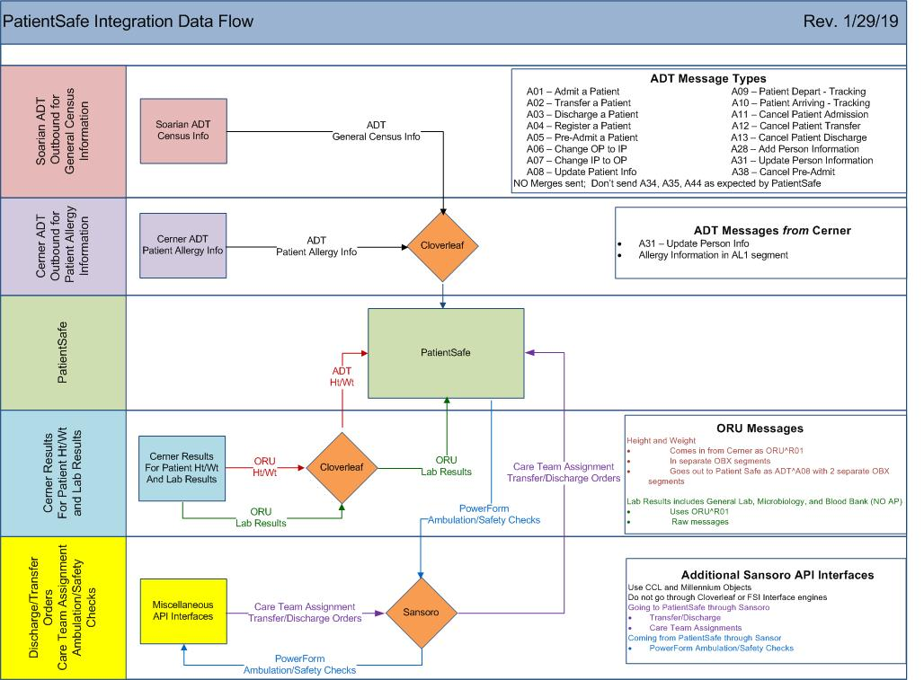

# 3. Requirements

## 3.1 Functional Requirements

Provide detail for the below functional requirements. The message transformation requirements for the components defined in this specification should be specified in section 4.2 of this document.

|  |  |  |
| --- | --- | --- |
| **Cloverleaf** |  |  |
| **Number** | **Requirement Name** | **Requirement Description** |
| FR.2019.1.0 | For the pilot project, only send Mease Countryside Hospital patients to PatientSafe. | Only MCS is included in the pilot project. A Tcl advanced filter is used to only let patients from MCS hospital go to PatientSafe in this first phase. |
| FR.2019.2.0 | Only send A31 messages with AL1 segments to PatientSafe. | When allergy information is added, modified, or removed on a patient at the person level in Cerner PowerChart, an HL7 A31 message is generated containing AL1 segments. A Tcl advanced filter is used to ascertain that only A31s with AL1 segments are sent to PatientSafe. |
|  |  |  |
|  |  |  |
|  |  |  |

## 3.2 Non-Functional Requirements

Provide concise detail for the below non-functional requirements. The below requirements must be evaluated for every project.

|  |  |  |
| --- | --- | --- |
| **Cloverleaf** |  |  |
| **Number** | **Requirement Name** | **Requirement Description** |
| NFR.20XX.1.0 | Click here to enter text. | Click here to enter text. |

## 3.3 Messaging Protocols

Below are listed the details for the messaging protocols that will be leveraged for this integration.

### 3.3.1 Inbound to the BayCare Cloverleaf From Cerner

* TCP MLLP Server Connection

### 3.3.2 Outbound to PatientSafe

* TCP MLLP Client Connection

# 4. HL7 Messaging

## 4.1 Messaging Format

### 4.1.1 Segments

The segments utilized for this interface are:

MSH

EVN

PID

PV1

{AL1}

{ZAL}

Note that the messages are sent “raw” from Cerner to PatientSafe.

At this point, PSS is not using information from the Z segments.

*Message Construction Notes:*

*[Square Brackets] – Optional*

*{Curly Brackets} – Repeatable*

*MSH – Message Header*

*EVN – Event segment*

*PID – Patient ID segment*

*PV1 – Patient Visit segment*

*AL1 – Allergy Information segment*

*ZAL – Allergy Additional Information*

### 4.1*.*2 Messaging Event Types

Below are the messages types necessary for this integration

Supported ADT Events

|  |  |
| --- | --- |
| **Event Type** | **Description** |
| A31 | Update Person Information |

### 4.1*.*3 Cloverleaf Configuration Files

For each HL7 interface specified in Section 2 of this document, identify the Cloverleaf Configuration Files: Variants, TCL Scripts, Xlates, etc.

HL7 Variants: None

Xlate: None

TCL Script: tpsAdvHL7Filter.tcl, tpsHL7ChangeData

### 4.1.4 Cloverleaf Site Location

Production = soarf_adt_ent_18_p, cerner_adt_siu_bar_5_p

Test = soarf_adt_ent_18, cerner_adt_siu_bar_5

## 4.2 Data Transformation Requirements

tpsHL7ChangeData: move the BayCare MRN sent by Cerner from PID.2 to PID.3, where PSS expects to find it.

4.3 Sample Message

Inbound to Cloverleaf from Cerner: (Inpatient)

MSH|^~\&|HNAM|CERNER|WHH|SOARIAN|20190124143757||ADT^A31|Q4430942445T5823996600||2.3||||||8859/1

EVN|A31|20190124143757|||5804113

PID|1|7000059295^^^BayCare MRN^MRN^SOARIAN|7000059295^^^BayCare MRN^MRN^SOARIAN~810070592^^^BayCare CMRN^Community Medical Record Number^SOARIAN||WHHTEST^FOURONE^^^^^Current||19900401|F||White|8475 MAIN STREET^^Tampa^FL^33619^^Home||(813)555-1212^PRN||EN|S|Catholic|6000090827^^^BayCare FIN^FIN NBR^SOARIAN||||Non HIS or LAT|||0

PV1|1|I|MIC^M01^01^WHH^^Bed(s)^WHH|Elective|||1093920969^Lnfgj^Lmlcu^N^^^^^NPI Number^Personnel^^^National Provider Identifier^CACTUS~MS061690^Lnfgj^Lmlcu^N^^^^^BayCare Dr Number^Personnel^^^ORGANIZATION DOCTOR^CACTUS|||MED||||RP|||1093920969^Lnfgj^Lmlcu^N^^^^^NPI Number^Personnel^^^National Provider Identifier^CACTUS~MS061690^Lnfgj^Lmlcu^N^^^^^BayCare Dr Number^Personnel^^^ORGANIZATION DOCTOR^CACTUS|I||Undetermined|||||||||||||||||||WHH||Active|||20181113132000

AL1|1|DA|d00116^penicillin^Multum Drug|MO|369546013

ZAL|ADD||52891979|52891979|Allergy|Active|369546013^Hives^995935|Family|||20190124143756|^Pullicin^Richard^^^^^^^Personnel|0

AL1|2|DA|d00212^diphenhydrAMINE^Multum Drug

ZAL|SNAPSHOT|20181214112749|52879127|52879119|Allergy|Canceled|||||20181214112749|^Perez^Jane^^^^^^^Personnel|0

AL1|3|DA|d00967^baclofen^Multum Drug|MO|406765011

ZAL|SNAPSHOT|20190124143559|52891973|52891973|Allergy|Active|406765011^Skin rash^995935|Patient|||20190124143559|^Pullicin^Richard^^^^^^^Personnel|0

AL1|4|DA|d00683^Lidocaine Viscous^Multum Drug|MO

ZAL|SNAPSHOT|20181214112834|52879131|52879131|Allergy|Active|||||20181214112834|^Perez^Jane^^^^^^^Personnel|0

Outbound from Cloverleaf to PatientSafe: (Inpatient)

MSH|^~\&|HNAM|CERNER|WHH|SOARIAN|20190124143757||ADT^A31|Q4430942445T5823996600||2.3||||||8859/1

EVN|A31|20190124143757|||5804113

PID|1|7000059295^^^BayCare MRN^MRN^SOARIAN|7000059295^^^BayCare MRN^MRN^SOARIAN~810070592^^^BayCare CMRN^Community Medical Record Number^SOARIAN||WHHTEST^FOURONE^^^^^Current||19900401|F||White|8475 MAIN STREET^^Tampa^FL^33619^^Home||(813)555-1212^PRN||EN|S|Catholic|6000090827^^^BayCare FIN^FIN NBR^SOARIAN||||Non HIS or LAT|||0

PV1|1|I|MIC^M01^01^WHH^^Bed(s)^WHH|Elective|||1093920969^Lnfgj^Lmlcu^N^^^^^NPI Number^Personnel^^^National Provider Identifier^CACTUS~MS061690^Lnfgj^Lmlcu^N^^^^^BayCare Dr Number^Personnel^^^ORGANIZATION DOCTOR^CACTUS|||MED||||RP|||1093920969^Lnfgj^Lmlcu^N^^^^^NPI Number^Personnel^^^National Provider Identifier^CACTUS~MS061690^Lnfgj^Lmlcu^N^^^^^BayCare Dr Number^Personnel^^^ORGANIZATION DOCTOR^CACTUS|I||Undetermined|||||||||||||||||||WHH||Active|||20181113132000

AL1|1|DA|d00116^penicillin^Multum Drug|MO|369546013

ZAL|ADD||52891979|52891979|Allergy|Active|369546013^Hives^995935|Family|||20190124143756|^Pullicin^Richard^^^^^^^Personnel|0

AL1|2|DA|d00212^diphenhydrAMINE^Multum Drug

ZAL|SNAPSHOT|20181214112749|52879127|52879119|Allergy|Canceled|||||20181214112749|^Perez^Jane^^^^^^^Personnel|0

AL1|3|DA|d00967^baclofen^Multum Drug|MO|406765011

ZAL|SNAPSHOT|20190124143559|52891973|52891973|Allergy|Active|406765011^Skin rash^995935|Patient|||20190124143559|^Pullicin^Richard^^^^^^^Personnel|0

AL1|4|DA|d00683^Lidocaine Viscous^Multum Drug|MO

ZAL|SNAPSHOT|20181214112834|52879131|52879131|Allergy|Active|||||20181214112834|^Perez^Jane^^^^^^^Personnel|0

**Go Live Date for PSS ADT interface: January 22, 2019**

# Appendix A: Risks and Concerns

|  |  |  |  |  |  |  |  |  |
| --- | --- | --- | --- | --- | --- | --- | --- | --- |
| **Project Name** |  |  | | |  |  |  |  |
| **Number** | **Risk / Concern** | **Comment** | **Mitigation** | | |  |  |  |
|  |  |  | |  | |  |  |  |

# Appendix B: Issues List

This is a dynamic list of the open issues related to the IDBB that remain to be solved, including but not limited to TBDs, pending decisions, information needed, conflict awaiting resolution, and the like.

|  |  |  |  |  |  |  |  |  |
| --- | --- | --- | --- | --- | --- | --- | --- | --- |
| **Project Name** |  |  | | |  |  |  |  |
| **Number** | **Issue** | **Comment** | **Fix** | | |  |  |  |
|  |  |  | |  | |  |  |  |

* End of document